HW3 — Modeling (CRISP-DM 4)
Project: Real-Time Human Activity Recognition from Smartphone Sensors.
Models trained:
two classical baselines on a reduced 6-feature set (Logistic Regression,
Random Forest)
four deep models on the raw 128×9 signal (Main, Patch and CNN-Transformer,
and the dual-branch Fourier+Transformer), plus an architecture ablation and a sensor ablation.

4.1 Select Modeling Technique

Output — Modeling Technique
We treat HAR as supervised multi-class classification of 2.56 s windows into six activities. We use
two complementary techniques on two representations of the same windows:
- Classical models on 6 engineered features.
- Logistic Regression — linear, transparent reference.
- Random Forest — non-linear tree ensemble.
- Transformers on the raw signal (learn their own features via self-attention):
- Main Transformer — per-timestep tokens, sinusoidal positional encoding, CLS pooling.
- Patch Transformer — 8 timesteps per token (patch_size = 8).
- CNN-Transformer — 1-D conv front-end feeding the Transformer.
- Fourier+Transformer — dual-branch: one encoder over the time signal, one over the
per-channel FFT log-magnitude spectrum, fused before classification (our flagship model).
This lets us compare feature-based classical ML against deep models on the raw waveform, and test
whether explicit frequency information helps.

Output — Modeling Assumptions
- Each 2.56 s window (128 samples × 9 channels) is an independent sample.
- Train/test subjects never overlap → scores estimate generalisation to new people.
- The 6 features are standardised (train statistics); the raw signal is z-scored per channel (trainstatistics) so all channels share a scale.
- 2.56 s holds enough motion/periodicity to identify the activity; labels are reliable.

4.2 Generate Test Design

Output — Test Design
- Split : Official UCI subject-disjoint partition: 7,352 training windows (21 subjects) and
2,947 test windows (9 unseen subjects), used once for final evaluation.
- Feature reduction (classical track). We keep the 6 features with the highest mutual
information with the label, computed on the training set only:
tBodyAcc-max()-X
tGravityAcc-min()-Y
tBodyAccJerk-max()-X
tGravityAcc-max()-Y
tBodyAccMag-max()
tGravityAccMag-max().
These combine movement-intensity features
- Validation (deep track). From the training pool we hold out 5 subjects (1,764 windows) as a
subject-wise validation set. models train on the remaining 5,588 windows, and we keep the best
validation-macro-F1 checkpoint. The validation set drives all architecture choices (the ablation).
- Metrics
macro-F1 , accuracy, per-class precision/recall/F1, confusion matrices,and ECE (calibration). Fixed seed = 42.

4.3 Build Model

Output — Parameter Settings
- Classical:
LogReg C = 2.0, max_iter = 2000 (+ StandardScaler)
Random Forest 600 trees , min_samples_leaf = 2
- Transformers (shared core):
Dimension model = 64, 4 heads, 2 layers, feed-forward 128, dropout 0.15 Sinusoidal PE, CLS pooling. Optimiser AdamW (lr 1e-3, weight decay 1e-4), cosine schedule, batch 128, gradient clipping 1.0, 20 epochs, best-validation checkpoint.
Fourier+ Transformer =c136,326 parameters.

Output — Models
Eight trained models: 2 classical (6 features), 4 deep (raw signal), plus 7 ablation variants and
5 sensor-group variants (validation/secondary studies).

Output — Model Description
Final test-set performance (subject-disjoint, 2,947 windows):
Model | Input | Test acc | Macro-F1
Fourier+Transformer (time + FFT) | raw 128×9 | 0.905 | 0.902
Patch Transformer (patch 8) | raw 128×9 | 0.901 | 0.899
CNN-Transformer hybrid | raw 128×9 | 0.896 | 0.896
Main Transformer (per-timestep) | raw 128×9 | 0.883 | 0.882
Logistic Regression | 6 features | 0.787 | 0.785
Random Forest | 6 features | 0.742 | 0.739

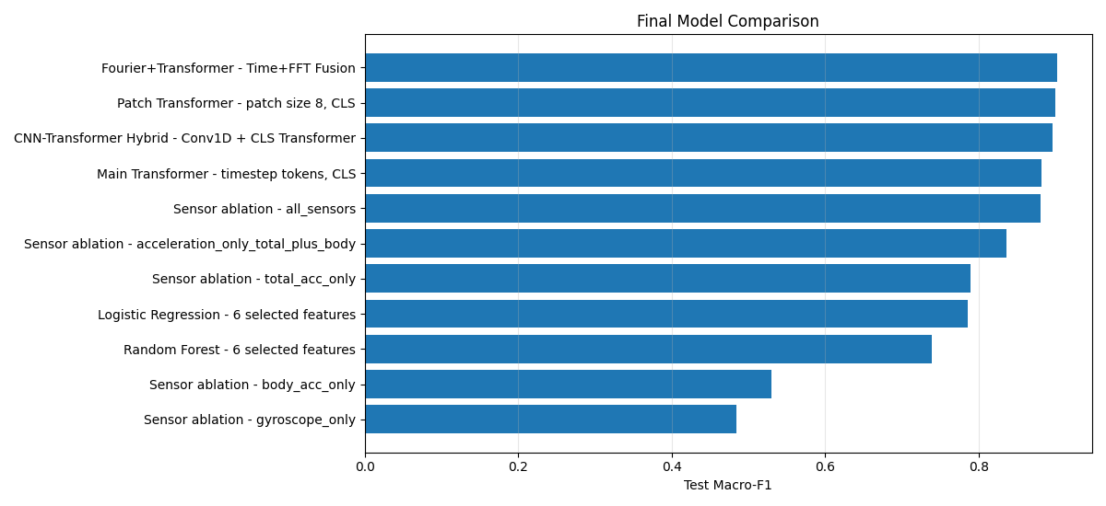
Final model comparison by test macro-F1.
- Fourier+Transformer is best (macro-F1 0.902) and notably fixes the hard static postures: its
SITTING F1 = 0.899 and STANDING F1 = 0.909 vs. 0.803 / 0.839 for the Main Transformer — the FFT branch separates near-static activities.
- Patch tokenisation helps (0.899 > 0.882): fewer, less-noisy tokens generalise better.
- The CNN front-end is competitive (0.896). The Main Transformer is the weakest deep model and is well-calibrated (ECE = 0.048).
- The 6-feature classical models (0.785 / 0.739) are a deliberately minimal baseline: six numbers capture coarse structure but not fine within-group distinctions.
- Across every model, LAYING is perfect and no dynamic activity is confused with a static one, all error is within the walking group or within the sitting/standing pair.
Difficulty: the Transformers overfit the training subjects (train F1 ~0.96–0.98 vs. test ~0.88–0.90),
reflecting between-subject variability.

4.4 Assess Model

Output — Model Assessment
The ranking above (best → worst by macro-F1) puts the four Transformers ahead of the 6-feature
baselines, with the Fourier+Transformer first.
Confusions : The only meaningful errors are SITTING ↔ STANDING and mix-ups among the three
walking variants. LAYING is always correct. The Fourier+Transformer's frequency branch is what
shrinks the SITTING/STANDING confusion.
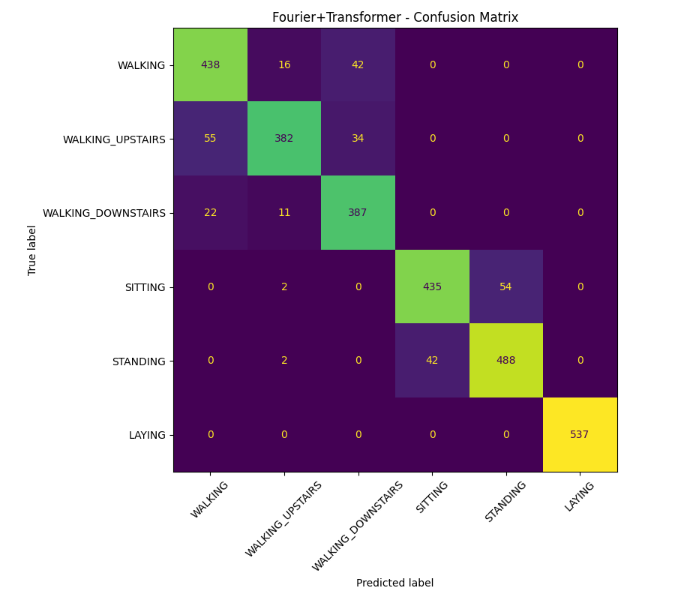
Fourier+Transformer — test confusion matrix.
Per-subject. Accuracy varies strongly by person (0.64 for subjects 9–10 up to 1.00 for subject
24) a few hard subjects drive most of the error the main generalisation limitation.
Ablation (validation macro-F1): best is patch 8 + sinusoidal PE + CLS (0.937).
Removing positional encoding is worst (0.897). extra depth/heads add little. CLS ≥ mean pooling.
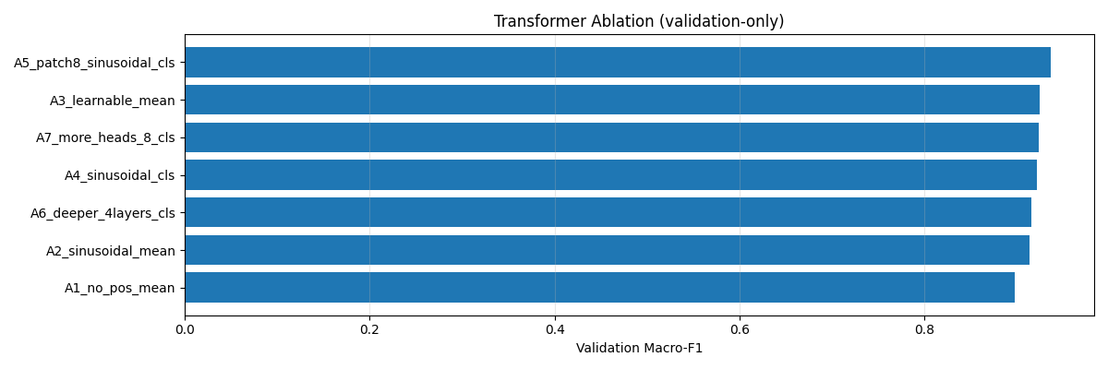
Transformer architecture ablation (validation macro-F1).
Sensor ablation (test macro-F1): all 9 sensors 0.881. total-acc only 0.789. gyroscope only
0.484. The accelerometer carries most of the signal, the gyroscope alone is weak, and using all
sensors is best , answering question about which signals matter.
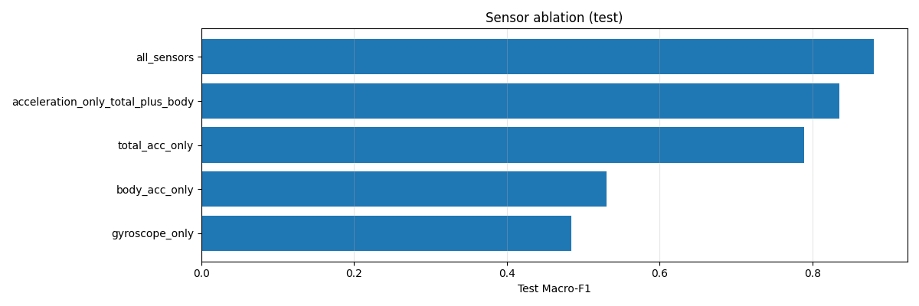
Sensor-group ablation (test macro-F1).
Against the success criteria: a working pipeline, full multi-class metrics, and clear separation
of the core activities met by the deep models (~0.90).

Output : Revised Parameter Settings
- Adopt patch tokenisation + CLS + sinusoidal PE as the default recipe, and the
Fourier+Transformer as the final model (most accurate, most robust on the hard classes).
- Residual error sits in SITTING/STANDING and a few subjects, not in any single hyper-parameter, so
further grid search has limited upside.
- Next iteration: light regularisation / early stopping to close the overfitting gap, data
augmentation (jitter, rotation) for cross-subject robustness, and if a stronger classical
baseline is wanted — relaxing the 6-feature limit. This closes the build → assess loop.

